WARRINGTON ROAD CLUB

Event Secretary:

### 25 MILE 4 UP TEAM TIME TRIAL

Malcolm Horner

26 Browning Drive

Winwick Park

Warrington

Founded 1923

WA2 8XLF

Tel. 07894 209557

[](http://www.cyclingtimetrials.org.uk/Home/tabid/36/Default.aspx)

##### Promoted for and on behalf of Cycling Time Trials under their Rules and Regulations on Tuesday 18th June 2024 at 6.45 pm

**COURSE - J2/9** **TIMEKEEPERS**: Martin Jackson and Ian Ross

**HEADQUARTERS:** Cranage Village Hall, Knutsford Road, Cranage, CW4 8EQ.

Open from 5.30 pm but please note we have to vacate the hall & car park by 10.30pm

#### COURSE DETAILS

**START** at “JS2” mark in Bomish Lane (Jodrell Bank to Goostrey). At telegraph pole No 2 approx 300 yds

west of the A535. Proceed east to and forward on A535 to:-

**CHELFORD ISLAND** **2.169 ml**

Second exit left on the A537 to Seven Sisters Lane at:-

**OLLERTON 5.219 ml**

Left along the lane to the A50, left to Twemlow Lane at:-

**CRANAGE**  **11.408 ml**

Left along the lane to join the A535 to Twemlow Green, left to:-

**CHELFORD ISLAND 18.064 ml**

Second exit left on the A537 to Seven Sisters Lane, left along the

lane to join the A50, left to:-

**FINISH 25.000 ml**

Opposite the northern gate post of a field gate almost opposite the entrance to

Mount Pleasant nursing home, approx 500 yds past crossroads after Drover

Arms Public House.

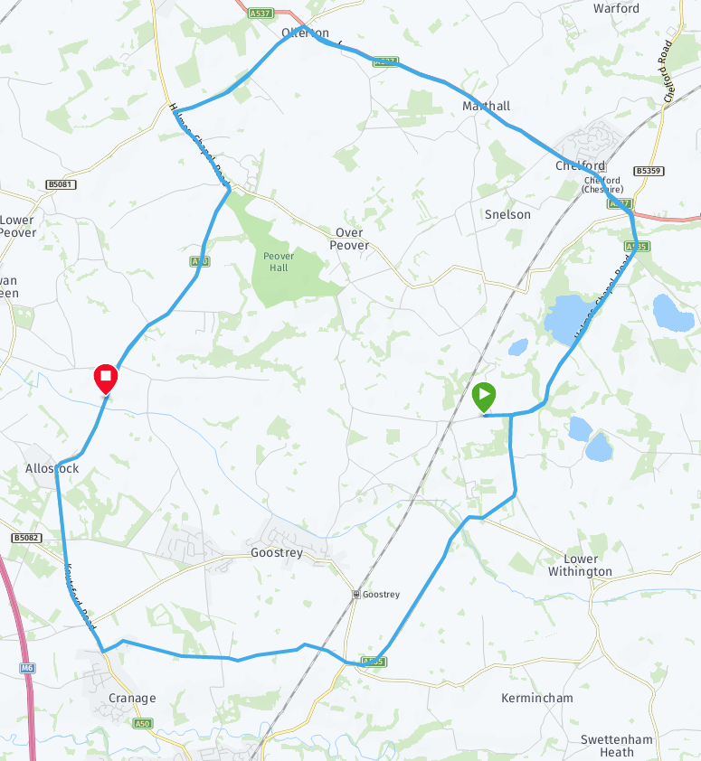

J2/9 - 25 miles TT Course

**Directions to start**: **The Start is approx 4.4 miles away** **so allow sufficient time. F**rom the HQ turn left along the A50. After 0.5 miles turn right into Goostrey Lane and continue through the village to turn left into Blackden Lane at St Lukes Church. Follow lane for approximately 1.5 miles, ignoring left and right forks, to a WRC flag at the start.

**General notices**

**1.** After finishing, continue along A50 for approximately 3 miles to the HQ on the right.

**2**. Riders must not stop at the finish but should continue to the event HQ where times will be displayed.

**HQ**

**3**. NO PARKING AT THE START OR FINISH

**RACE NUMBERS:** Available at HQ. Sign the Sign On sheet when you collect your number. *All competitors are required personally to sign the signing out sheet when returning their number.* ***Failure to do so will result in the competitor being recorded as DNF.﻿***

**PRIZE LIST**

|  |  |  |  |
| --- | --- | --- | --- |
|  | 1st | 2nd | 3rd |
| Fastest team | £160 | £120 | £80 |
| Fastest team on Road Bikes | £100 |  |  |
| Fastest team with a lady  Fastest team with a youth | £100  £40 |  |  |

# ONE TEAM ONE PRIZE

**Road Bike Criteria**: the road bike can possess drop or straight handlebars; tri-bars, clip-on bars or Spinaci bars are not allowed; no disc wheels; both front & rear wheels must have at least 12 spokes each; the maximum rim depth allowed is 90mm.

**Special Note for Under 18s:** I have had a high entry from under 18s for this event which is great to see however please ensure you have a completed and signed parental consent form to hand in at sign on. No Parental Consent = No Ride

**Important Notices**

1.      **CTT Regulations 14(i), 14(j), 15: COMPULSORY LIGHTS & HELMETS**No competitor will be allowed to start without a working white front light and red rear light, either flashing or constant, and fitted to their machine in a position clearly visible to other road users. All competitors must wear a properly affixed helmet which must be of hard/soft shell construction. **No lights or no helmet = no ride.**

**2. CHELFORD ISLAND** Riders must negotiate Chelford Island in a safe and sensible manner in accordance with CTT regulation 20 and the rules of the road.  Riders must be able to brake and stop at the island if traffic conditions require this.  Riders MUST NOT USE their tri-bars between the first bollard they pass on entering the island and the last bollard they pass leaving it.  Any rider seen to be in breach of this regulation will be disqualified from the event and maybe reported for further disciplinary action

3. Under CTT regulation 32(d) all riders in a team (composite team or club team) are required to wear clothing of a similar colour and design.

4. **Care at Road Junctions**

Riders must exercise caution at all junctions. **Any competitor whose riding causes him/her to cross the white lines when approaching or leaving a junction will be liable to disqualification from the event and may be reported to the District Committee for further disciplinary action**.

A competitor who swings out to the right before executing a left turn should ensure that the road behind is clear of traffic before doing so. The practice is not encouraged by the District Committee and competitors who ride in this manner are warned that in many circumstances this manœuvre will be regarded as a contravention of regulation 19(a)(b)(d).

5. **Riders must take extra care when existing from Seven Sisters Lane onto the A50.**

6. Be aware that there is a double bend shortly after turning into Twemlow Lane at Cranage. Riders need to anticipate this and be prepared to negotiate it in a safe manner. In wet weather the metal covers and edges become a skid risk. Please take care.

7. Parking

Vehicles must not be parked, however briefly, in any part of the access area to the Mount Pleasant Nursing Home, opposite the finish.

**HQ**

[](http://www.cyclingtimetrials.org.uk/Home/tabid/36/Default.aspx) 